**Manuals for ‘Manage Banner’**

**Brief of the ‘Manage Banner’ –** This is the page where we manage the Home page banners.

**1. How to manage banners -.**

Steps:

1. Login to the site and go to ‘Masters’ tab and click on ‘Manage Banners’.
2. On ‘Manage banner’ page the listing of banners will display.
3. Here we can edit and delete the existing banners.
4. Here we also add new banner with the banner redirect link, on clicking of ‘Add’ button.
5. Upload the banner image and give the banner link and click on ‘Save’ button for saving new banner.
6. The update content will display on home page.

1.

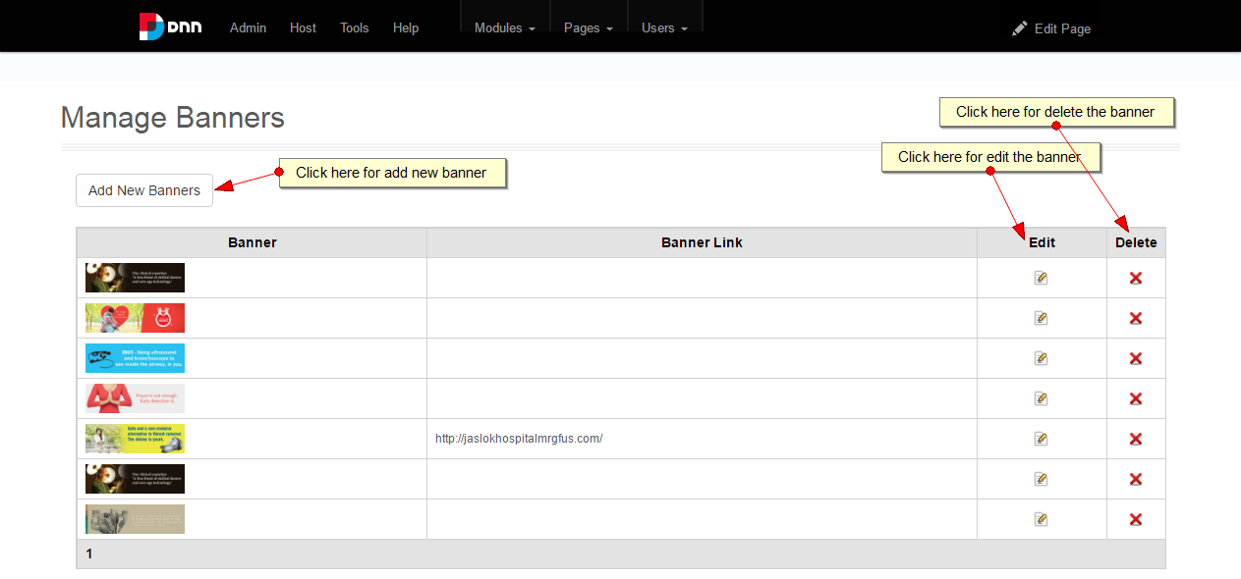

2.

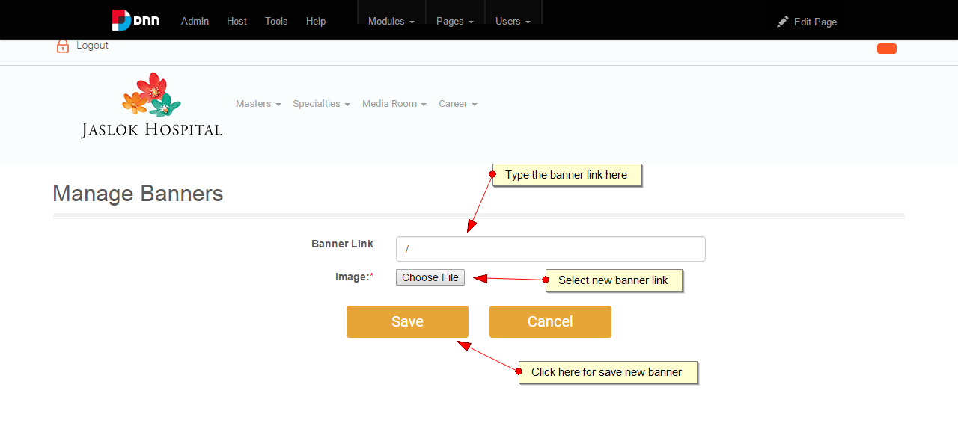

3.

